**Lab 03**

Emre Can Şen - 21902516

*Department of Electrical and Electronics Engineering, Bilkent University, 06800 Ankara, Turkey*

1. **Introduction**

In this lab, the gain, phase and delay margins of a system was calculated with a mathematical model. Then these values were tested on the real system and the real values of these margins were found. For the first part of the lab, the model that was calculated in the previous labs were used to find gain, phase and delay margins via bode plots. In the second part, the real system is built and output is captured. Then the real values of gain, phase and delay margins were found.

1. **Laboratory Content**

**Part 1**

From the first lab, it was found that:

$$G(s)=\frac{13.583}{0.191989s+1}$$

Using the formulas provided in the manual, constants are calculated as:

$$τ_{LPF}=15.626$$

$$K_{C}=0.147243$$

Then plugging these all to the formula given in the manual it is found:

$$G_{C}\left(s\right)=\frac{1}{s+15.626}*\frac{0.147243s+11.7794}{s}$$

Then $G_{p}\left(s\right)$ with Pade approximation is found which was also used in the previous lab:

$$G_{P}\left(s\right)=\frac{13.583}{0.191989s+1}*\frac{1-0.005s}{1+0.005s}$$

Finally, the open loop transfer function of the system is obtained.

$$G\left(s\right)=G_{P}\left(s\right)*G_{C}(s)$$

$$G\left(s\right)=\frac{13.583}{0.191989s+1}*\frac{1-0.005s}{1+0.005s}*\frac{1}{s+15.626}*\frac{0.147243s+11.7794}{s}$$

Then the Bode plot of the system is obtained with MATLAB bode function.

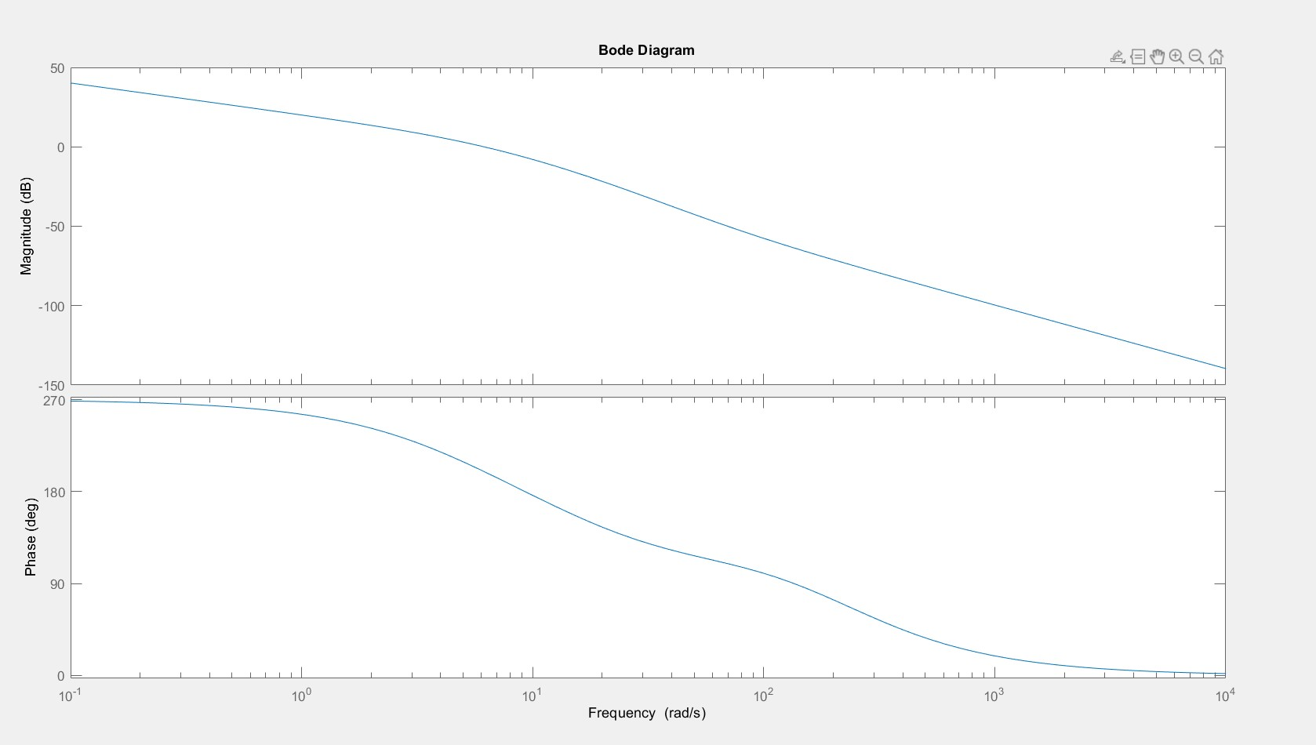

Figure 1- Bode Plot of the Closed Loop System

Next, the phase and gain margins of the system will be determined via the Bode plot.

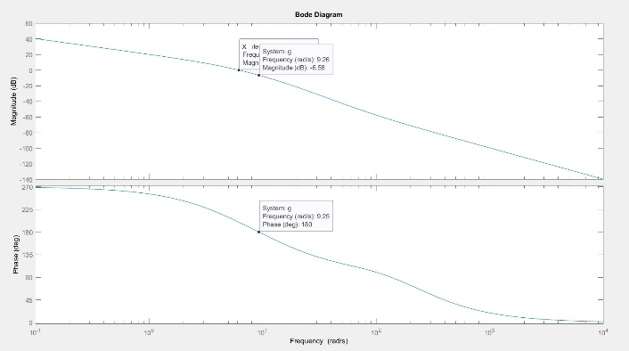

Figure 2- Gain Margin Calculation Values

The frequency at phase equals to 180 degrees was found to be 9.25 rad/s. Then magnitude is found to be -6.58dB at that frequency. So the gain margin of the system is 6.58dB. Moreover, the critical gain of the system is:

$$20log(K_{C})=6.58dB$$

$$K_{C}=2.133$$

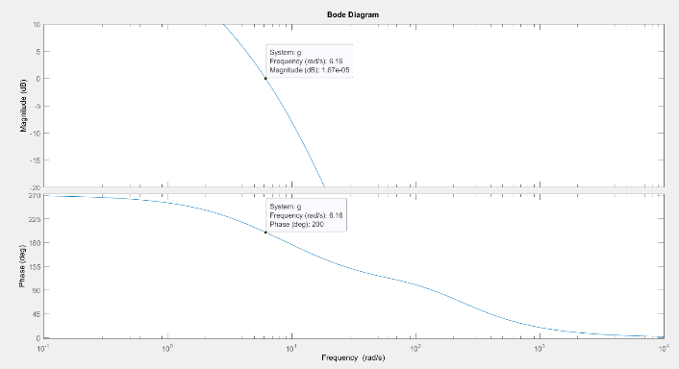

Figure 3- Phase Margin Calculation Values

Following that the frequency at 0dB is determined to be 6.16 rad/s. The phase at that point is then calculated as 200 or -140 degrees. Hence the gain margin of the system is calculated as:

$$ϕ_{PM}=180-160=20°$$

Then using the crossover frequency and phase margin, delay margin of the system is calculated as:

$$Delay Margin=\frac{ϕ_{PM}*(\frac{π}{180})}{6.16}=0.05667$$

**Part 2**

In the second part, like the previous labs, the phase and delay margins will be obtained with the real(hardware) implementation of the DC. This is done by applying a 40u(t) step input to the system. Then, the phase and gain margins of the real system will be found by testing values that are close to the values found in the previous part. Different margin input values will be determined such that the systems are stable, marginally stable and unstable.

First, the outputs of the systems will be tested for different gain margins such that K=1.3, 1.8, 2.0.

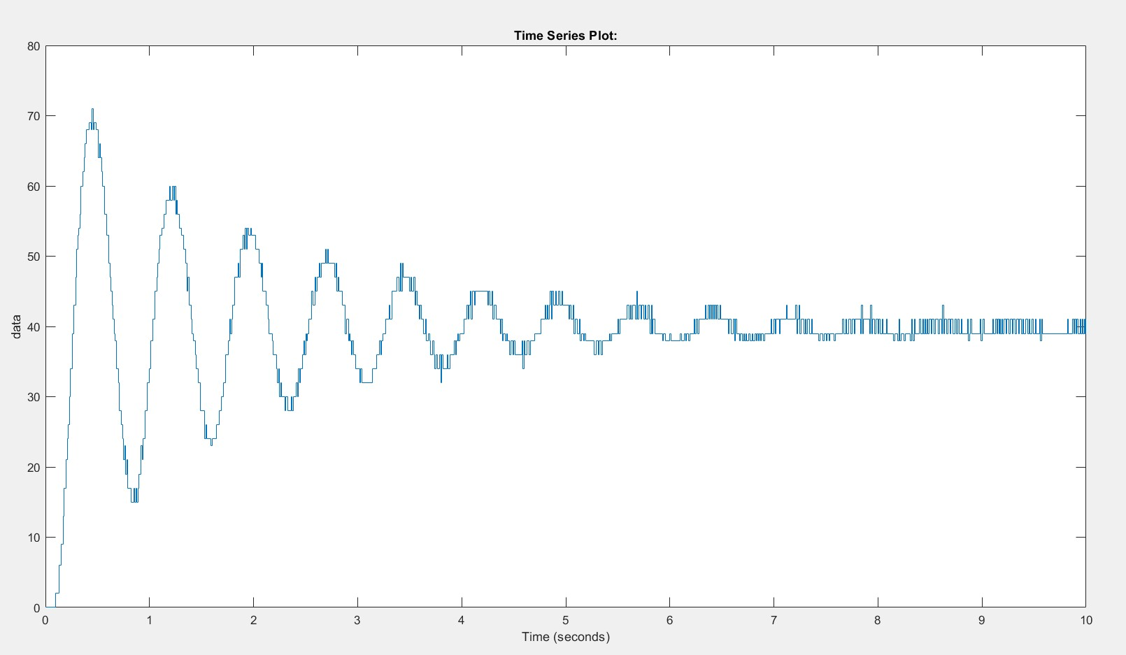

Figure 4- System Output for K=1.3

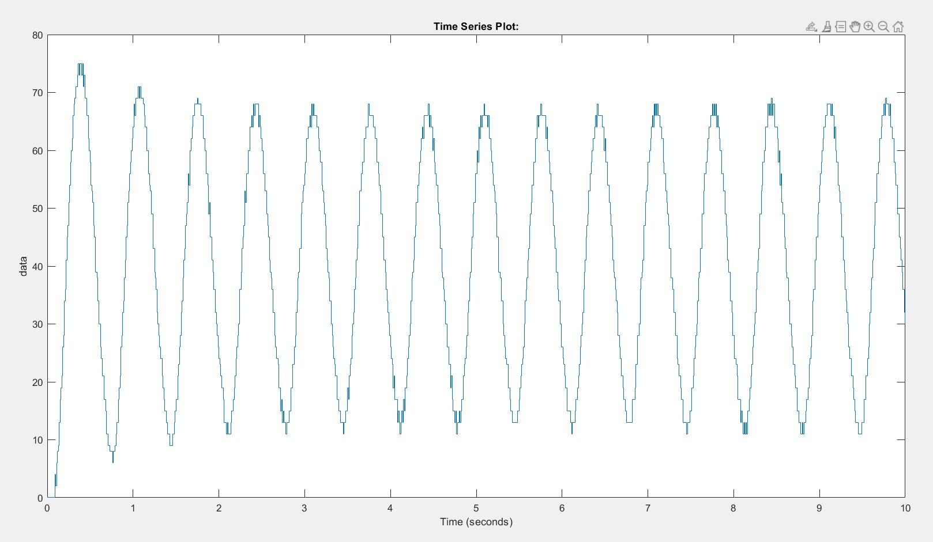

Figure 5- System Output for K=1.8

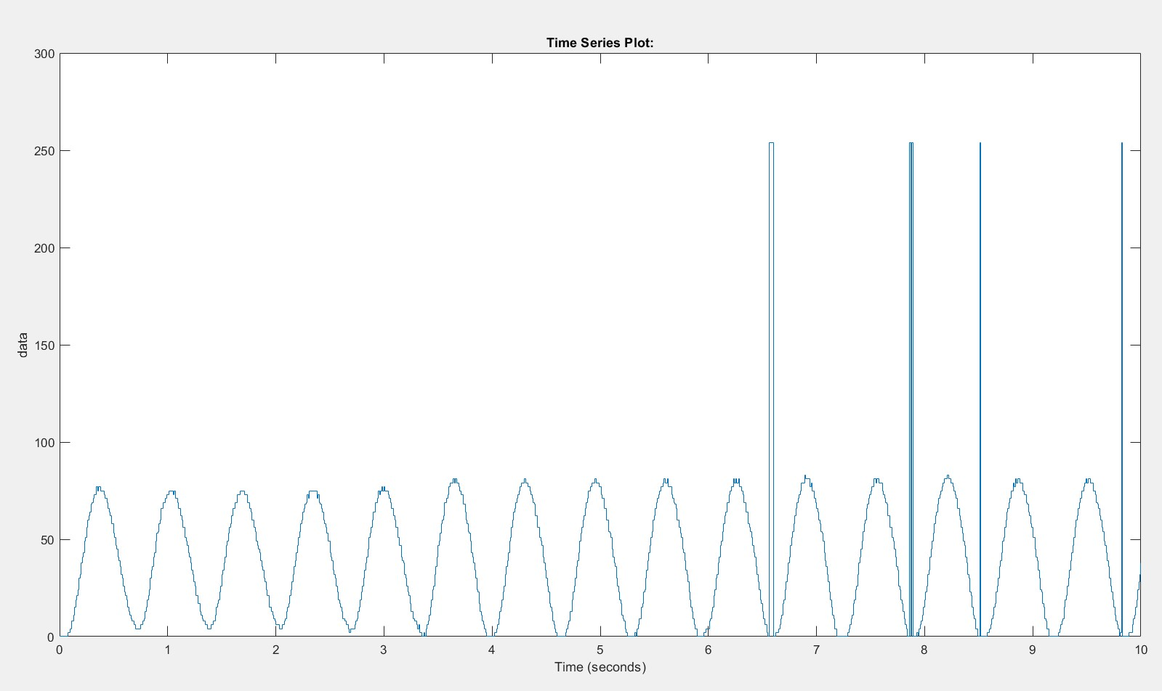

Figure 6- System Output for K=2.0

As it can be seen in the 4th figure, the system converges to zero after some time so the system is stable for K=1.3. Then, when K=1.8, the output oscillates with constant amplitude after 3 seconds, so the system is marginally stable. Finally, K=2.0 is plugged and it is seen that magnitude of the oscillation of the system grows as time passes, so the system is unstable. It was concluded that the critical gain of the real system was 1.8 and gain margin was:

$$20log(1.8)=5.105dB$$

So the theoretical margin was found to be 6.58dB and the hardware was 5.11dB.

Then the same procedure was done with delay margins with values: 0.010, 0.028, 0.035 sec.

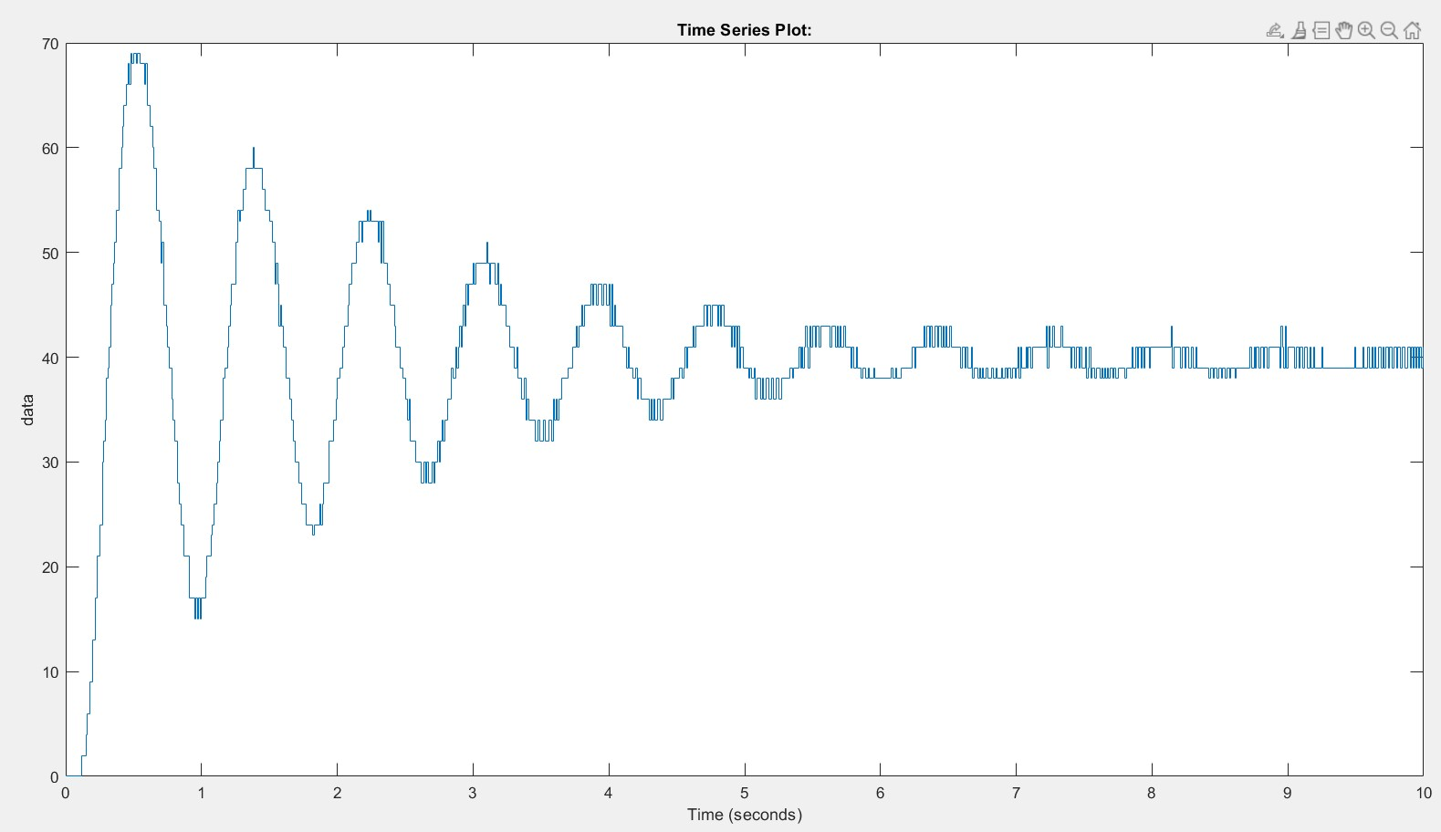

Figure 7- System Output for Delay=0.010s

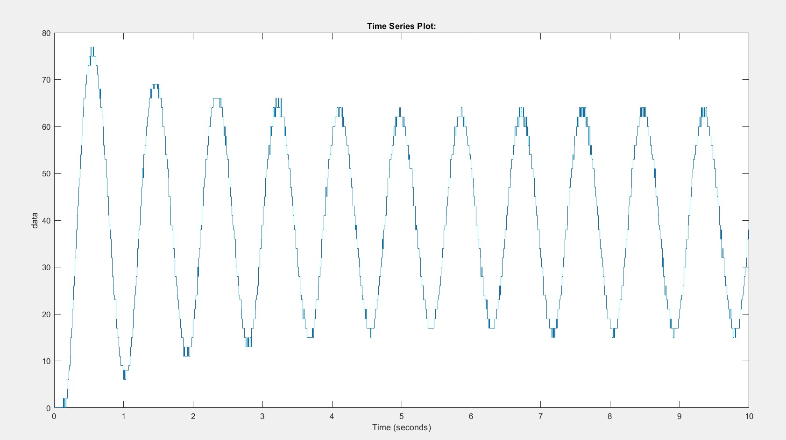

Figure 8- System Output for Delay=0.028s

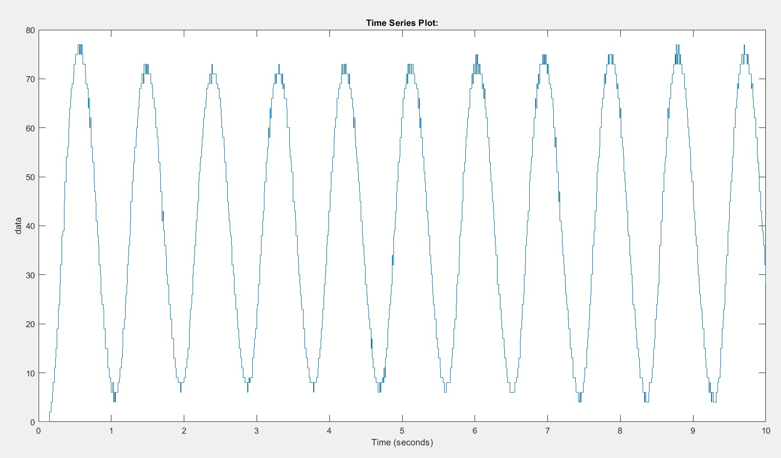

Figure 9- System Output for Delay=0.035s

The same logic with the gain margin applies here. So the system is stable for delay=0.010s, marginally stable for delay=0.028s and unstable for delay=0.035s. Hence the delay margin was found to be 0.028 seconds and the theoretical delay margin was found as 0.05667 seconds.

1. **Conclusion**

In the end, using the Bode plot of the obtained transfer function from the previous labs, the gain, phase and delay margins were found. Then these values are tested in the real case, using the DC motor to verify the margins. Three K and delay values are obtained which are determined utilizing the theoretical values as a basis. These values are found such that the system is stable, marginally stable and unstable. Finally using the marginally stable cases for both delay and gain, the real delay and gain margins are found

Both the delay and the gain margins were found to be smaller than the theoretical case. The error might be due to transfer function that is obtained in the previous labs. The obtained result might be different that the ideal case so there is an error. There might also be the effect of noise because the hardware setup is not perfect. Additionally, the mathematical model used is a first order approximation. This approximation might be the cause of the error.

**Appendix**

**MATLAB:**

g1=tf(13.583,[0.191989,1]);

g2=tf([0.147243,11.7794],[1,15.626,0]);

g3=tf([-0.005,1],[0.005,1]);

g=g1*g2*g3;

bode(g)

[Gm,Pm,Wcg,Wcp]=margin(g);

plot(velocity)